Name _________________________________________________
Each of the following melodies is based on one of the scales listed here. Write the name of the proper scale in the blank provided. Scales:
major natural minor harmonic minor melodic minor pentatonic chromatic whole tone
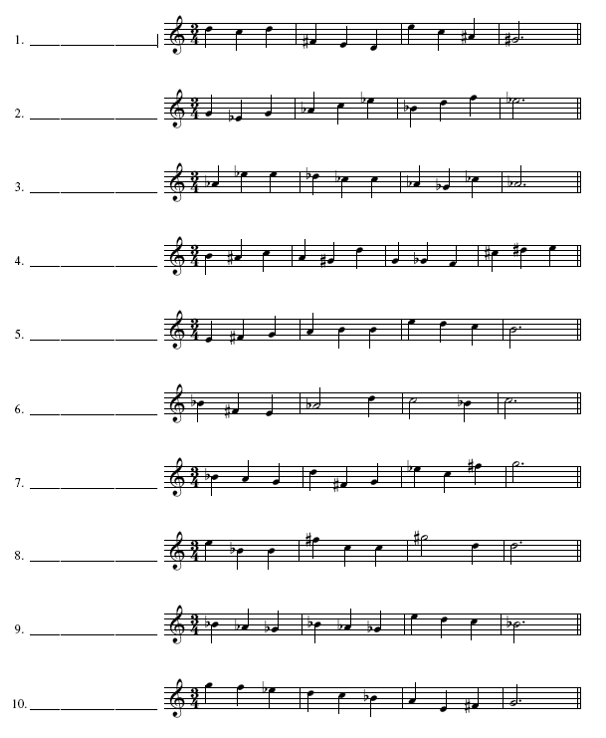

Add the correct accidentals to form the mode requested
