Borrowed chords | Definition  using chords that belong in the parallel key  (same tonal center, like D major and D minor)  Also called modal mixture  (mixing chords from different modes)
Which ones should I borrow? | Major keys most typically borrow these from the parallel minors:  - viiº7 (instead of vii7)  - iiº (instead of ii)  - ii7 (instead of ii7)  - iv (instead of IV)  - VI (instead of vi)  - III (instead of iii)  - VII (instead of viiº) | Minor keys mostly borrow:  - I (instead of i)  (commonly referred to as a Picardy third*)  ________________  The only chords major doesn’t borrow is v and i!
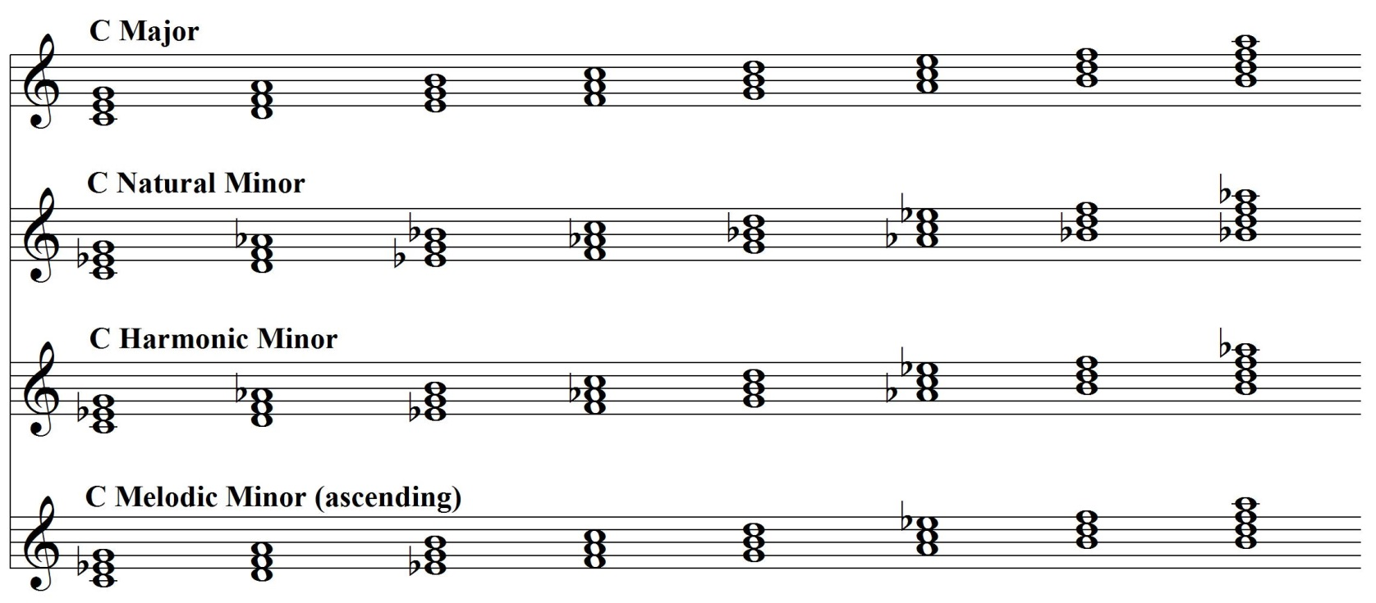
Here are the available chords in C Major and 3 forms of C Minor: 7th Chords

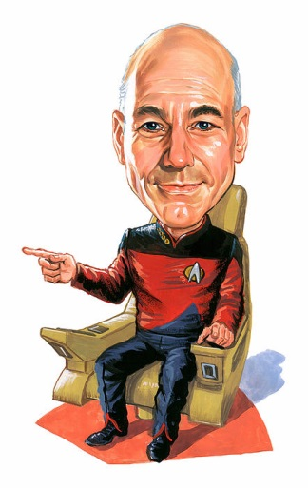
Borrowed chords generally have the same function as their tonal
counterparts, and usually resolve the same. An exception is the VI,
which usually resolves to V.
____________________________________

*Picardy third: when the last tonic chord of a minor piece is changed to major. The practice goes back as far as the 15th century, used most commonly in the 16th and 17th centuries, but is seen even later. Composers thought minor chords were dissonant and that a major chord sounded more stable and final. No one knows for sure why the term Picardy is used. It may be because the practice was common in a region of northern France called Picardie.

