Secondary  dominant | Definition*  a chord that behaves like a dominant chord, but does not belong in the key  points to a chord that is not tonic
So, how does a dominant chord behave?  A dominant chord is a major triad or Mm 7th chord; its root is a 5th above (or 4th below) tonic  SO  a secondary dominant does that for some other chord besides the tonic | As if I had my very own key  My secondary dominant chord would be:  PRETEND KEY SECONDARY DOMINANT  D A  Ab Db  B F#
Let me try! I can be a dominant to vi!  Hey, I could act like your dominant if I were major!  Add a sharp – now I’m a V of V! | Now I’m a V of vi!
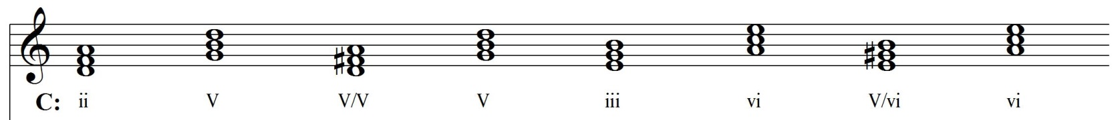  Cool! Makes me feel important like a tonic chord!  You’re not the boss of me! | Go for it! We can pretend to be in A minor!  Sweet!
Notice that the altered pitch that is required is also the leading tone to the chord it points to!
When part-writing, don’t double the altered pitch!
If the dominant is secondary, the tonicization is temporary
Why use a secondary dominant?  - it adds a different “color” to the harmony (major chords or Mm 7th chords brighten the harmony)  - it drives the harmonic motion forward by adding more tension (the altered pitch acts like a leading tone to the next chord)  - it can be used to modulate to a new key | How do you know if an altered chord  is a secondary dominant?  - If it is a major chord or Mm7th chord  - If the root of the altered chord is a 5th above (or 4th below) the chord that follows it  It’s probably a secondary dominant!

