Secondary  leading tone chords |  | Definition*  a chord that behaves like a leading tone chord, but does not belong in the key  points to a chord that is not tonic
So, how does a leading tone chord behave?  A leading tone chord is a diminished triad or 7th chord; its root is a 5th half step below tonic  SO  a secondary leading tone chord does that for some other chord besides the tonic |  | If I had my very own key  My leading tone chord would be:  KEY LEADING TONE CHORD  D C#  Ab G  B A#
Hey, I could act like your leading tone chord if I were diminished!  Let me try! I can be a leading tone chord to vi!  Add a sharp – now I’m a viio of V! |  | Now I’m a viio of vi!
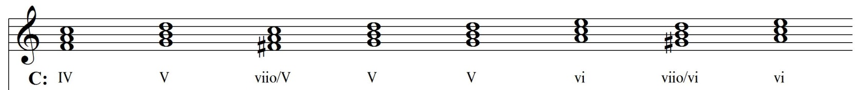  Go for it! We can pretend to be in A minor!  Wait! Where are you leading me??  Cool! Makes me feel important like a tonic chord! |  | Sweet!
Notice that the altered pitch that is required is also the leading tone to the chord it points to!
When part-writing, don’t double the altered pitch!

Why use a secondary  leading tone chord?  - it adds a different “color” to the harmony (diminished triads or 7th chords darken the harmony)  - it drives the harmonic motion forward by adding more tension (the altered pitch acts like a leading tone to the next chord)  - it can be used to modulate to a new key | How do you know if an altered chord  is a secondary leading tone chord?  - If it is a diminished triad or 7th chord  - If the root of the altered chord is a half step below the chord that follows it  It’s probably a secondary leading tone chord!

