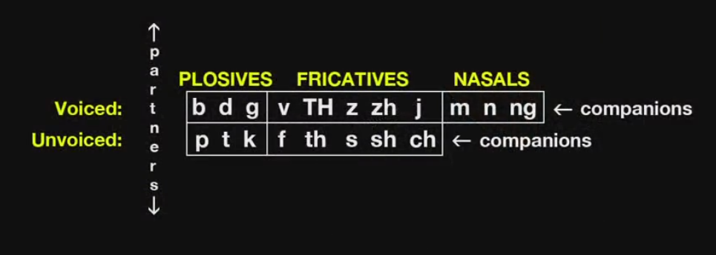

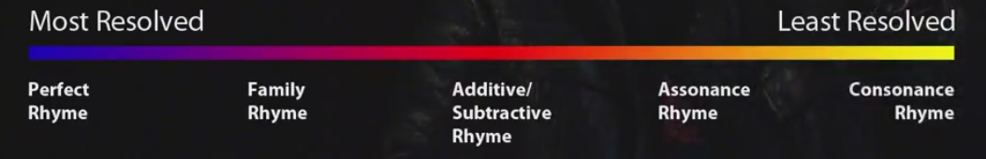

Perfect rhyme:
A lovely day to have some fun
Hit the beach and get some sun

Family rhyme:
A lovely day to have some fun
Hit the beach, bring the rum

Additive
A lovely day to have some fun
Hit the beach, get some lunch

Subtractive
Hit the beach and get some lunch
A lovely day to have some fun

Assonance rhyme:
A lovely day to have some fun
Hit the beach, fall in love

Consonance rhyme:
A lovely day to have some fun
Hit the beach, bring it on

